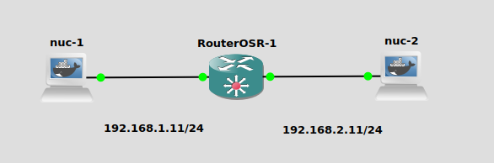

1. ***Aplicamos dirección IP a los NUCS***

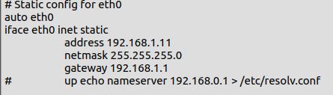

1. ***Usamos los comandos para el router***

system/identity/set name=R1

ip/address/add address=192.168.1.1/24 interface=ether1

ip/address/add address=192.168.2.1/24 interface=ether2

ip/firewall/filter/add chain=forward src-address=192.168.1.11 action=drop

* ***Con este comando paramos el Ping del Nuc hacia el router***

ip/firewall/filter/add chain=input src-address=192.168.1.11 action=drop

* ***Con este comando protegemos el Ping del Nuc hacia el router***

ip/firewall/filter/add chain=input src-address=192.168.1.11 dst-address=192.168.1.1 action=drop

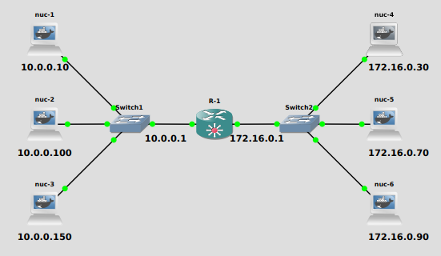

**Desde la red 10.0.0.0/24 se puede comunicar con toda la red 172.16.0.0/24 exepto con 172.16.0.70 y .90**

ip/address/add address=10.0.0.1/24 interface=ether1

ip/address/add address=172.16.0.1/24 interface=ether2

ip/firewall/filter/add chain=forward src-address=172.16.0.70 action=drop

ip/firewall/filter/add chain=forward src-address=172.16.0.90 action=drop

* **Cuando tengamos estas dos redes excluidas podríamos crear una lista de direcciones con el comando:**

ip/firewall/address-list/add address=172.16.0.70 list=prohibido

ip/firewall/address-list/add address=172.16.0.90 list=prohibido

* **Y una vez hecha podemos excluirlas todas a la vez**

ip/firewall/filter/add chain=forward dst-address-list=prohibido action=drop

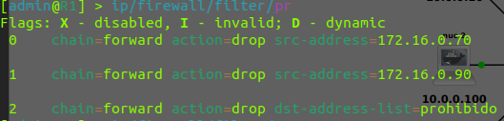

* Si vemos una configuración igual que esta podremos borrar las dos primeras opciones

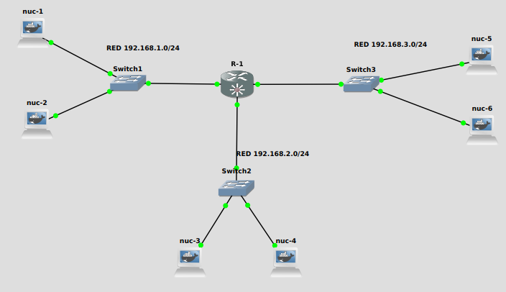

**R1:**

/ip address

add address=192.168.1.1/24 interface=ether1 network=192.168.1.0

add address=192.168.2.1/24 interface=ether2 network=192.168.2.0

add address=192.168.3.1/24 interface=ether3 network=192.168.3.0

/ip firewall filter

add action=drop chain=forward src-address=192.168.3.0/24

/ip firewall filter

add action=accept chain=forward connection-state=established

add action=accept chain=forward connection-state=new src-address=\

192.168.3.0/24

add action=drop chain=forward